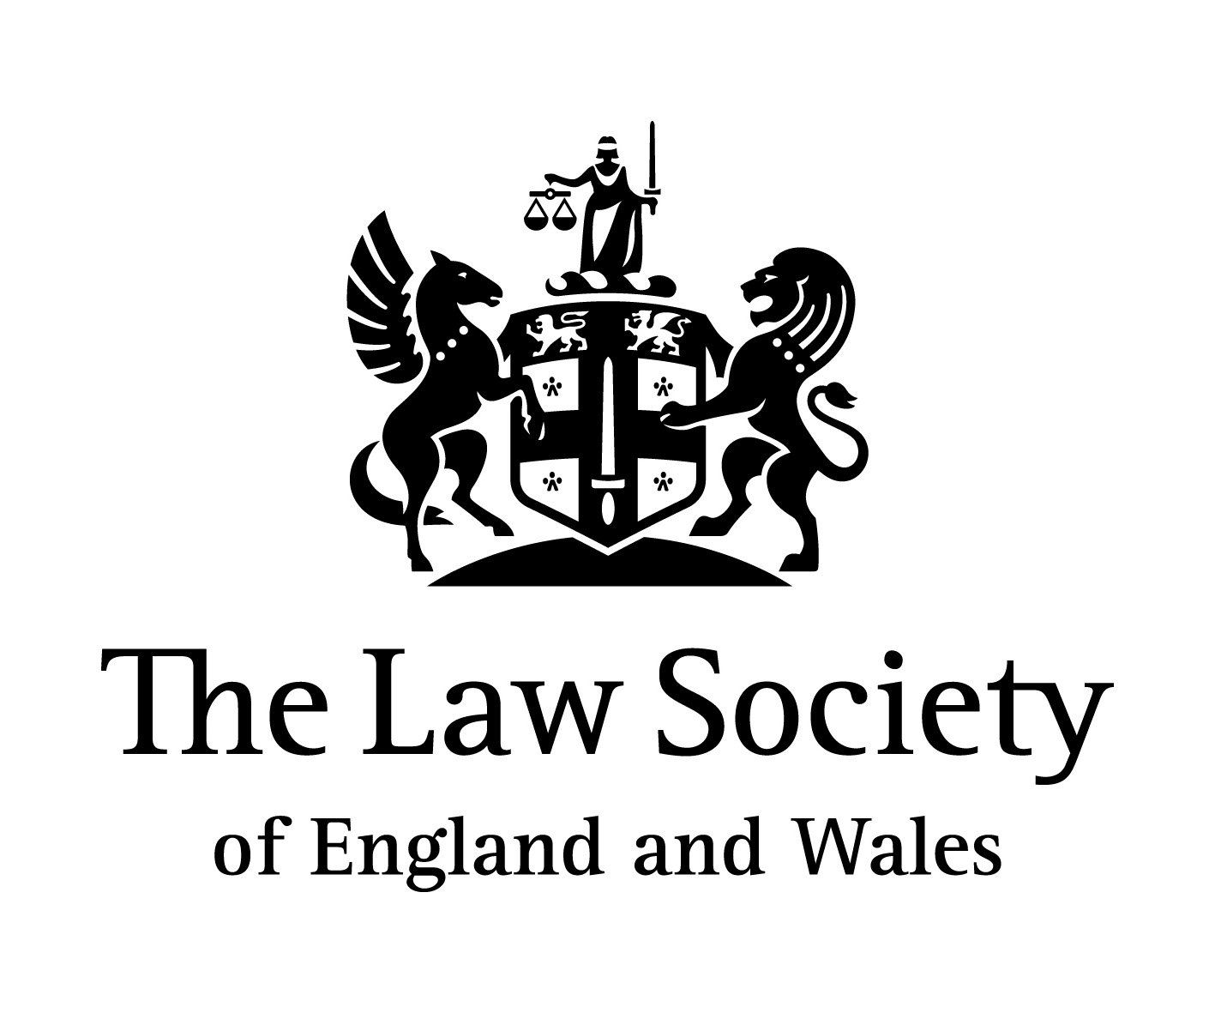
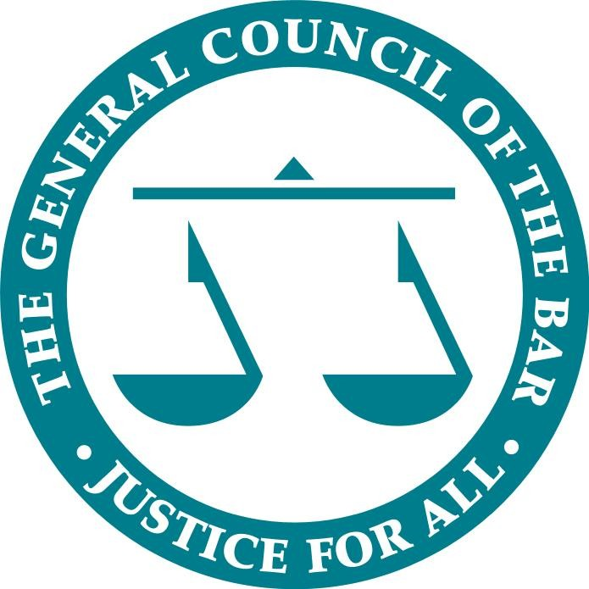

Opportunity to host Russian lawyers as part of the Russo-British Young Lawyers Exchange Programme, February 2012

Under the auspices of the Ministry of Justice of the Russian Federation and the Ministry of Justice of the United Kingdom, a young lawyer exchange scheme has just been launched, operated by the Federal Chamber of Advocates, the Law Society of England and Wales and the Bar Council of England and Wales, supported by the British Russian Law Association.

The aim is for promising young lawyers from both jurisdictions to gain a better understanding of each country’s legal systems and professional standards.

The programme will begin on 13 February 2012 when up to ten young Russian lawyers will come to London for six weeks to participate in introductory training in the English legal system and to complete placements in chambers and law firms. Later in the year, lawyers from England & Wales will be invited to apply for the opportunity to be placed in a Russian law firm for three weeks.

Programme objectives

The overall aim of the programme is to;

- Raise participants’ awareness of how the English and Russian legal systems operate, how the legal profession in the host country functions and how to work most effectively with colleagues from the other jurisdiction;

- Enable practitioners to better understand the host legal market and the opportunities it offers;

- Facilitate professional networking between practitioners;

- Build a network of lawyers which may form the foundation of other projects (e.g. business development missions or professional seminars);

- Build an alumni network and develop new channels for utilising the familiarity of member lawyers with each others’ professions;

- Build a better relationship between the partners which will assist both business development and cooperation on professional standards.

Ways to get involved in the London programme

The Law Society and the Bar Council are looking for interested law firms/chambers to get in touch who would like to offer a placement to a young Russian lawyer for three weeks during the programme which is due to commence on 13 February 2012.

Programme outline

The programme will begin with two days of seminars and trips introducing the lawyers to the English legal system, the main legal institutions (the Court system, including visits to the High Court, the Supreme Court and the Old Bailey (Central Criminal Court), Bar Council, Law Society) and the work of the profession.

There will be additional teaching elements, through which participants will gain familiarity with various aspects of English law, including the English dispute resolution process.

Participating law firms/chambers have an additional opportunity to put together a one-off seminar/work shop during the six weeks for the full delegation at their London office. The focus of the seminars would ideally be legal topics of an international commercial nature, legal skills such as advocacy and negotiation and business skills such as chambers/law firm management and marketing. Topics could include seminars on sources of law, common law/equity, legal institutions, roles of barristers/solicitors and professional ethics.

Sponsorship/hosting opportunities at networking events may also be available

Criteria of the Russian lawyer

  - Graduates of law who have passed the national lawyers’ examination in Russia and have between 2 and 10 years Post Qualification Experience (PQE) in Russia
  - Have excellent written and oral English
  - Have some experience in one or more areas of legal practice of significance to Russia-UK legal relations and have strong personal motivation and an ability to adapt to different environments
  - Are currently working for a Russian law firm or as an in-house counsel for a Russian company, and are supported (though not necessarily financially) by their law firm or company to participate in the programme
  - Have experience in working the private sector and specifically in international legal services

Criteria of the participating law firm/barrister chamber

- Be able to place one young Russian lawyer for three consecutive weeks during which you will provide high quality work experience and training in fields relevant to international legal practice.
- Have experience in international commercial work, in-house legal skills such as advocacy and negotiation and business skills such as chambers/law firm management and marketing
- The placement must take place in your London office.
- Barristers or solicitors willing to undertake the teaching during the placement.
- Be able to assign 1-2 mentors to assist the lawyer during their 3 week placement in the law firm/chamber
- Be able to consider running a one-off seminar/workshop at your London office, on a topic of your choice

How to get in involved

If you are interested in offering a placement to a young Russian lawyer please contact either the Bar Council or the Law Society for further information.

The Law Society of England and Wales international@lawsociety.org.uk

The Bar Council of England and Wales IntlEvents@barcouncil.org.uk

The deadline to apply is 28 November 2011. Please register your interest as soon as possible to avoid disappointment.

Supported by the British-Russian Law Association

