SPONSORS

CONFERENCE STRATEGIC PARTNER

CONFERENCE PARTNERS
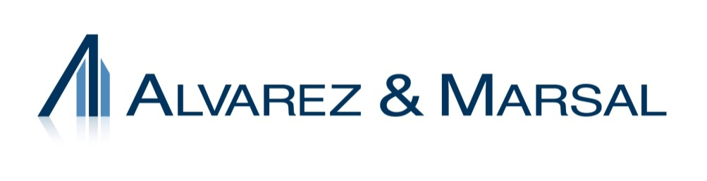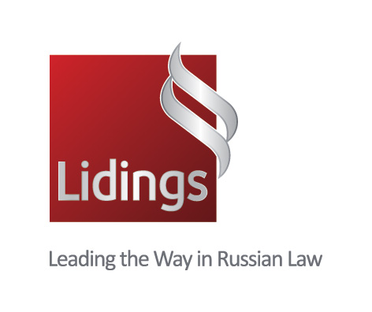

LUNCHEON SPONSOR CONFERNCE PADS & PENS SPONSOR

PRE CONFERENCE DINNER SPONSOR

PANEL SPONSOR

NETWORKING BREAK SPONSORS

MEETING SUPPORTER

MEDIA SPONSORS

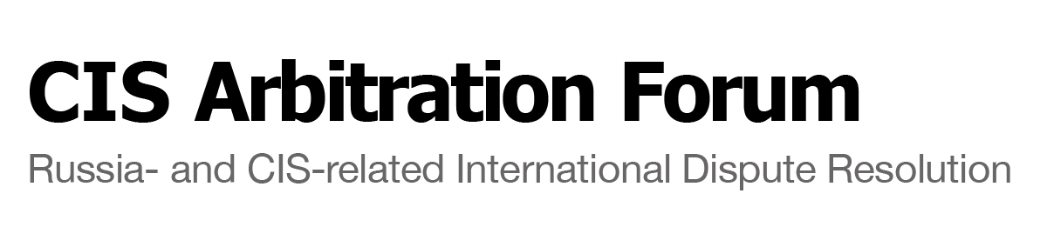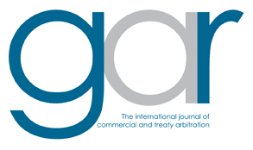

COOPERATING ENTITIES
Current as of 5.13.13

Organizational Partner

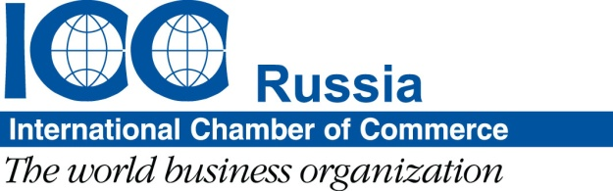

Cooperating Entities
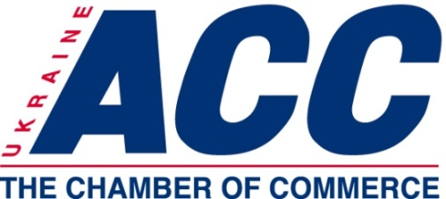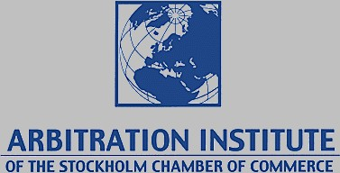

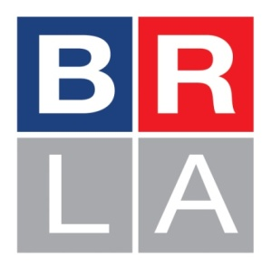 CIS Leading Counsel Network (LCN) CIS Local Counsel Forum
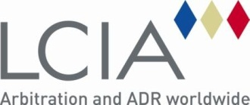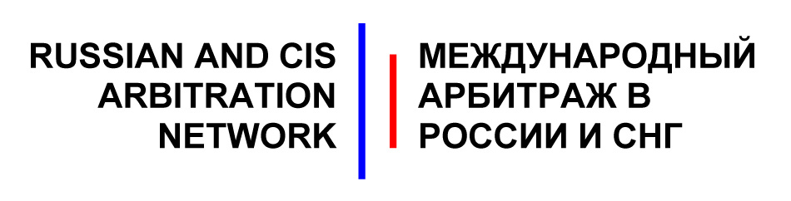
Russian Federal Chamber of Lawyers
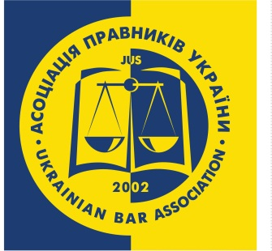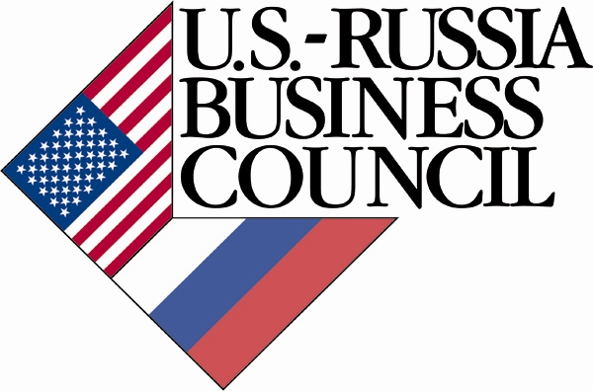

Program Planning Committee
SECTION CHAIR 2013-14
Gabrielle Buckley • Vedder Price P.C. • Chicago, Illinois, USA

CONFERENCE CO-CHAIRS
Rupert D'Cruz • Littleton Chambers • London, United Kingdom
Glenn P. Hendrix • Arnall Golden Gregory LLP • Atlanta, Georgia, USA
Anna Kozmenko • Curtis, Mallet-Prevost, Colt & Mosle LLP • New York, New York, USA
Ilya Nikiforov • Egorov Puginsky Afanasiev & Partners • St. Petersburg, Russia

CONFERENCE DEPUTY CO-CHAIRS
Timur Aitkulov • Clifford Chance • Moscow, Russia
Gene Burd • Arnall Golden Gregory LLP • Washington, DC
Thomas A. Firestone • Baker & McKenzie - CIS, Limited • Moscow, Russia
Laura Hardin • Charles River Associates • Moscow, Russia
Christopher R. Kelley • University of Arkansas School of Law • Fayetteville, Arkansas, USA
Petter Pettibone • Hogan Lovells LLP • New York, New York, USA
Andrey Zelenin • Lidings • Moscow, Russia

STEERING COMMITTEE
Marney Cheek • Covington & Burling LLP • Washington, DC, USA
Karl Hepp de Sevelinges • Gide Loyrette Nouel LLP • New York, New York, USA
Svetlana Derkach • ICC Russia • Moscow, Russia
Dmitri Evseev • Arnold & Porter LLP • London, United Kingdom
Kathryn Hendley • University of Wisconsin • Madison, Wisconsin, USA
Jeffrey Hertzfeld • Dentons • Paris, France
Vladimir Khvalei • Baker & McKenzie LLP • Moscow, Russia
Maksym Kodunov • Integrites Law • Kyiv, Ukraine
Sergey Korolev • McBreen & Kopko LLP• New York, New York, USA
Alexey Kostin • International Commercial Arbitration Court at the Chamber of Commerce and Industry of the Russian Federation (MKAS) • Moscow, Russia
Maria Kostytska • W & S SELARL • Paris, France
Maxim Kulkov • Freshfields Bruckhaus Deringer LLP • Moscow, Russia
Audrey B. Lamb • American Bar Association Section of International Law • Washington, DC, USA
Nick Marsh • DLA Piper • London, United Kingdom
Michelle Mattingly • American Bar Association Section of International Law • Washington, DC, USA
Vladimir Melnikov • Herbert Smith • Moscow, Russia
Alexander Muksinov • Muranov, Chernyakov & Partners • Moscow, Russia
Irina Nazarova • Engarde • Kyiv, Ukraine
Alexandra Orlova • ICC Russia • Moscow, Russia
Elena Ovcharova • Pepeliaev Group • Moscow, Russia
Irina Paliashvili • RULG-Ukrainian Legal Group PA • Kiev, Ukraine
Noradèle Radjai • Lalive • Geneva, Switzerland
Steven Richman • Duane Morris • Princeton, New Jersey, USA
Martina Rozumberkova • BDO • Boston, Massachusetts, USA
Fredrik Ringquist • Mannheimer Swartling • Moscow, Russia
Vassily Rudomino • ALRUD • Moscow, Russia
Miroslava Schierholz • International Centre for Dispute Resolution • New York, New York, USA
Trina Sen • Egorov Puginsky Afanasiev & Partners • St. Petersburg, Russia
Tsisana Shamikalashvili • Scientific and Methodological Center for Mediation and Law • Moscow, Russia
Jessica L. Smith • American Bar Association Section of International Law • Washington, DC, USA
Vassili Touline • KeyBank N.A. • Cleveland, Ohio, USA
Elena Uspenskaya • Kachkin & Partners • St. Petersburg, Russia
Curry Wilson • American Bar Association Section of International Law • Washington, DC, USA

The listing of the Planning Committee was compiled as accurately as possible from Section records. If we have omitted your name or have it listed incorrectly, we sincerely apologize.
PROGRAM AGENDA

All events to be held at the Radisson Royal Hotel Moscow at 2/1 bid 1 Kutuzovskiy prospect, Moscow, Russia unless otherwise indicated.

7:30 AM REGISTRATION & BREAKFAST
Conference Hall Foyer

8:30 AM – 9:00 AM OPENING REMARKS
Conference Hall

Opening Remarks:
Sheila Gwaltney, Deputy Chief of Mission, Embassy of the United States, Moscow, Russia (Invited)
Veniamin Fedorovich Yakovlev, Adviser to the President of the Russian Federation, Moscow, Russia

9:00 AM – 10:30 AM CONCURRENT SESSION No. 1

Promoting Russia as a Seat of Arbitration: What are the Best Ways Forward?
Conference Hall

As part of the efforts currently underway in Russia to make Moscow an international financial center, there are related measures being undertaken in Russia to make Russia a seat of international commercial arbitration. This panel, which includes leading Russian arbitrators and leaders of the Russian arbitration institutions, as well as a representative of an international arbitration institution, will examine what it takes for a jurisdiction to be accepted as a seat of international commercial arbitration, where Russia is on that spectrum, and what needs to be done to enhance the likelihood that parties will select Russia as the seat of arbitration to resolve their commercial contracts.

Program Chair:
Peter Pettibone, Hogan Lovells LLP, New York, New York USA

Speakers:
Mark Appel, Senior Vice President, International Centre for Dispute Resolution, Europe, Middle East & Africa
Vladimir Khvalei, Baker & McKenzie LLP, Moscow, Russia
Alexey Kostin, Chairman of International Commercial Arbitration Court (ICAC), Moscow, Russia
Natalia Pavlova, The Supreme Arbitration Court of the Russian Federation, Moscow, Russia

Criminal Aspects of Cross-Border Litigation
Column Hall

This panel will focus on issues related to criminal law that frequently arise in cross-border arbitration and litigation proceedings. How can allegations of bribery, fraud and money laundering be proven or disproven? Where and how do you get the evidence? What evidentiary weight should arbitral tribunals give to the results of domestic criminal prosecutions? Should arbitration be stayed pending the outcome of a domestic prosecution? Can the confidentiality of arbitration proceedings be maintained against requests for evidence by national law enforcement agencies? What should you do if your client is facing extradition? What if your witnesses are incarcerated? How can the security risks in these cases best be managed? This panel will focus on these and other challenging questions and will provide practical comments and advice.

Program Chair:
Anna Kozmenko, Curtis, Mallet-Prevost, Colt & Mosle LLP, New York, New York, USA

Moderator:
Russell Carlsberg, Embassy of the United States, Moscow, Russia

Speakers:
Glenn Hendrix, Arnall Golden Gregory LLP, Atlanta, Georgia, USA
Kaj Hobér, Mannheimer Swartling, Stockholm, Sweden
Boris Kolmakov, Alvarez & Marsal, Moscow, Russia
Nikolaus Pitkowitz, Graf & Pitkowitz, Vienna, Austria

10:30 AM – 11:00 AM NETWORKING BREAK

11:00 AM – 12:30 PM CONCURRENT SESSION No. 2

Hot Topics in Investor-State Arbitration: Investor-State Arbitration at a Crossroads
Conference Hall

A recent United Nations study on investor-state arbitration noted that while a record number of treaty-based disputes were filed last year, some in the international community are openly questioning the value of the system and calling for reform. This panel will explore several areas that have received increased attention of late, including transparency, the scope of state responsibility, third-party funding, and enforcement. In particular, the panel will examine what these recent trends mean for the future of investor-state practice in Russia and the CIS.

Program Chair:
Marney Cheek, Covington & Burling LLP, Washington, DC, USA

Speaker:
Noradèle Radjai, Lalive, Geneva, Switzerland
Paulo Fohlin, Advokatfirman Odebjer Fohlin, Hong Kong, China
Miriam Harwood, Curits Mallet-Prevost Colt & Mosle LLP, New York, New York USA
Sergei Voitovich, Grischenko & Partners, Kyiv, Ukraine

Getting Paid: A Practical Session for Creditors and their Counsel
Column Hall

Winning an arbitration or a court case is usually not enough to get the money or other relief from the debtor. In fact it’s only the beginning of a lengthy and a challenging process of execution of court judgments and collecting debts. In Russia this process can be particularly painful. According to the statistics of the Federal Judicial Bailiffs Service in 2012 about 1.5 million of over 5 million total execution proceedings against legal entities have ended with no result, while the overall collectability rate was less than 20% of the actual amount sought. In this panel we will discuss how the collection process works in Russia, are there any ways to raise its efficiency and what are the particularities of the procedure in regards to various types of the debtor’s property (real estate, securities, receivables etc.).

Program Chair:
Andrey Zelenin, Lidings, Moscow, Russia

Speakers:
Artur Olegovich Parfenchikov, Federal Judicial Bailiff Service, Moscow, Russia (Invited)
Fedor Vyacheslavov, ALRUD, Moscow, Russia
Sergiy Shklyar, Arzinger, Kiev, Ukraine
Tatiana Menshenina, Simmons & Simmons, London, UK
Dmitry Zhdanukhin, Association of Corporate Collection, Moscow, Russia
12:30 PM – 1:30 PM NETWORKING LUNCHEON
Veranda Restaurant
Sponsored by:

1:30 PM – 3:00 PM CONCURRENT SESSION No. 3

Antitrust Law Chart for Private Claims
Conference Hall

As countries in the CIS region integrate ever more profoundly into the international economic system, so also must these nations' competition regulators. National antitrust authorities are establishing deeper connections with their foreign counterparts, becoming quite active in competition enforcement networks and quickly adopting best practices. Simultaneously investigations and prosecutions of anticompetitive behavior carried out by the US Department of Justice and the European Commission are quickly mirrored in Russia. And the Federal Antimonopoly Service of Russia has in fact enhanced its public visibility, including introducing Facebook and Twitter accounts -- already collecting thousands of "likes" -- in its efforts to increase its reach and effectiveness. Traditional paradigm that competition enforcement courts public interest is fading out. Increasingly private parties seek restitution based on anti-competitive conduct.

A broad range of issues in this domain – from anticompetitive behavior, private cartel enforcement and other unfair competition litigation, judicial review of enforcement agencies actions -- are pending in courts.

This session will explore the various forms antitrust-related disputes may take and provide an overview of recent developments in the region -- and possible future changes. Competent speakers will discuss private enforcement regimes in the US and Europe– class and group actions, particularly to enforce claims against price fixing cartels, as a possible model for the ongoing reform of private enforcement regimes in Russia and CIS; revisit arbitrability of antitrust matters – to what extent competition law issues can be resolved by commercial arbitration tribunals.

Program Chair:
Ilya V. Nikiforov, Egorov Puginsky Afanasiev & Partners, St. Petersburg, Russia

Speakers:
Andrew Bullion, Hausfeld LLP, London, United Kingdom
Michel Deckers, Boekel, Amsterdam, Netherlands
Aleksander Kinev, Federal Antimonopoly Service, Anti-Cartel Department, Moscow, Russia

The Cyprus Banking Crisis and CIS Related Disputes – A Panel Debate
Column Hall
Sponsored by:

The Cyprus Banking Crisis has had a profound impact on Russian and CIS interests. Accounts have been frozen, taxes have been levied on deposits and funds have been converted (unilaterally) into shares. This has caused widespread disruption and damage to CIS businesses. As a result of these restrictions companies have been unable to comply with their contractual obligations under (amongst others) sale of goods, M&A and finance agreements. Inevitably, this has led to a new wave of CIS related disputes – both in Cyprus and other jurisdictions. In this session leading practitioners from Cyprus, Russia, Ukraine and England will address the impact of this topical and rapidly developing issue. This panel debate will focus on identifying current ideas and strategies for overcoming the range of challenges that CIS businesses face as a result of the Crisis. The issues discussed will include:

- An update on the Crisis (the haircut tax, capital controls and consequential claims being pursued in Cyprus).
- CIS related disputes arising from the Crisis.
- Force majeure and frustration defences to Crisis related claims.
- Joining Cypriot Banks to claims as third parties.
- The effect of the Crisis on assets frozen in aid of legal proceedings.
- Possible claims that can be brought in other jurisdictions (including treaty based claims).

Program Chair:
Rupert D'Cruz, Littleton Chambers, London, United Kingdom

Speakers:
Robert Campbell, Faegre Baker Daniels. London, United Kingdom
George Georgiou, George Z. Georgiou & Associates LLC, Nicosia, Cyprus
Varvara Knutova, Pepeliaev Group, Moscow, Russia
Maksym Kodunov, Integrites International Law Firm, Kyiv, Ukraine

3:00 PM – 3:30 PM NETWORKING BREAK

3:30 PM – 6:30 PM PLENARY SESSION

Unfair Competition Between the Judicial System
Conference Hall

The Chairman of the Supreme Arbitrazh Court of the Russian Federation, Anton Ivanov named five examples of what he called “unfair completion” of legal systems of other countries which detrimentally affect Russian citizens and companies.

- extraterritorial application of laws of one country over the relationship that is subject to jurisdiction of another country;
- “pulling” of disputes that are subject to the jurisdiction of one country into the courts of another country based on flimsy grounds;
- Anti-suit injunctions prohibiting legal actions in the courts of another country;
- A so-called “merger” of international commercial arbitration and state courts in certain countries which makes it virtually impossible to set aside arbitration awards in the national courts of that country;
- Disregard of sovereign immunity

Russian Duma echoed the Judge’s concerns and introduced a bill which, if adopted, would allow Russian citizens or companies who suffered from the “illegal” decisions of foreign courts to seek compensation from the Russian Government and for the Russian Government then pursue actions against individuals, court, or governmental officials involved in the alleged wrongdoings against the Russian persons.

This panel will feature a mock argument that will involve one or more scenarios described by the Chairman Ivanov. The argument will be followed by a discussion further exploring the issue of the unfair competition between legal systems.

Program Chairs:
Timur Aitkulov, Clifford Chance, Moscow, Russia
Gene Burd, Arnall Golden Gregory LLP, Washington, DC USA
Nick Marsh, DLA Piper, London, United Kingdom

Panel of Commentators:
Nick Marsh, DLA Piper, London, United Kingdom
Vladislav V. Starzhenetsky, Supreme Arbitrazh Court, Moscow, Russia

Moot Court Participants
Russia:
Timur Aitkulov, Clifford Chance, Moscow, Russia
Alexei Dudko, Hogan Lovells, Moscow, Russia

US:
Maria Kostytska, Winston & Strawn, Paris, France & Washington, DC, USA

Advocate:
Johan Sidklev, Setterwalls, Stockholm, Sweden
Henrik Fieber, Roschier, Stockholm, Sweden

7:00 PM SPASO HOUSE RECEPTION
No. 10 Spasopeskovskaya Square
Sponsored by:

Spaso House has been the residence of American ambassadors in Moscow since the establishment of diplomatic relations between the United States and the former Soviet Union in 1933. The Spaso House stands one mile west of the Kremlin and not far from the Arbat, an ancient region of Moscow. It was completed in 1914 for Nikolay Aleksandrovich Vtorov, a wealthy merchant and manufacturer. The reception will be held in the main hall, which features a soaring domed ceiling and reputedly the largest house chandelier in Moscow, said to be the handiwork of the famous silversmith Mishakov. Russian writer Mikhail Bulgakov attended a party at the main hall in 1935, which inspired the scene of the Devil’s Ball in The Master and Margarita. The event promises to be a memorable opportunity to network with new friends and old.

NOTE: Simultaneous translation in Russian and English will be provided for all sessions

The ABA directly applies for and ordinarily receives CLE credit for ABA programs in AK, AL, AR, AZ, CA, CO, DE, GA, GU, HI, IA, IL, IN, KS, KY, LA, MN, MS, MO, MT, NM, NV, NY, NC, ND, OH, OK, OR, PA, SC, TN, TX, UT, VT, VA, VI, WA, WI, and WV. These states sometimes do not approve a program for credit before the program occurs. This course is expected to qualify for 7.5 CLE credit hours in 60-minute states, and 9.0 credit hours in 50-minute states. This transitional program is approved for both newly admitted and experienced attorneys in NY. For more information about CLE accreditation in your state, visit http://ambar.org/moscow2013 or contact Michelle Mattingly at michelle.mattingly@americanbar.org.

Scholarships are available for this program. For more information please contact Michelle.Mattingly@americanbar.org.

